

**NORTHERN SCHOOL**

Figurative Language

Weekly Lesson Plan

|  |  |  |
| --- | --- | --- |
| Teacher  Add your name here. | Grade Level and Subject  Insert grade and subject here. | Week of  Add date range. |

Learning objectives



At the end of the week, learners will be able to:

* Add the ﬁrst learning outcome or skill.
* Another learning outcome or skill here
* Another learning outcome or skill here

Materials and resources



|  |  |  |
| --- | --- | --- |
| Textbooks | 1. Add book title here. 2. Another book title here 3. Another book title here | Use this space for your notes. |
| Visual aids | 1. Add a link to a presentation here. 2. Another visual aid here 3. Another visual aid here | Use this space for your notes. |
| Other category | 1. Start your list here. 2. Add another item 3. List other resources here | Use this space for your notes. |

Lesson overview



|  |  |  |  |
| --- | --- | --- | --- |
| DAY | TOPIC | ACTIVITIES | NOTES |
| Monday | Introduction to Heat | Discuss sources of heat; class brainstorm activity  Exit ticket: What are three examples of heat energy? | Reinforce vocabulary before the lesson starts. |
| Tuesday | Conduction | Demonstrate how energy flows when a metal spoon is placed in hot water; students record observations  Quick Quiz: Five items on conduction | Prepare materials before the demo. |
| Wednesday | Another topic here | Summarize the the key activities and include a way to check understanding. | Add notes for differentiation or support. |
| Thursday | Another topic here | Summarize the the key activities and include a way to check understanding. | Add notes for differentiation or support. |
| Friday | Another topic here | Summarize the the key activities and include a way to check understanding. | Add notes for differentiation or support. |

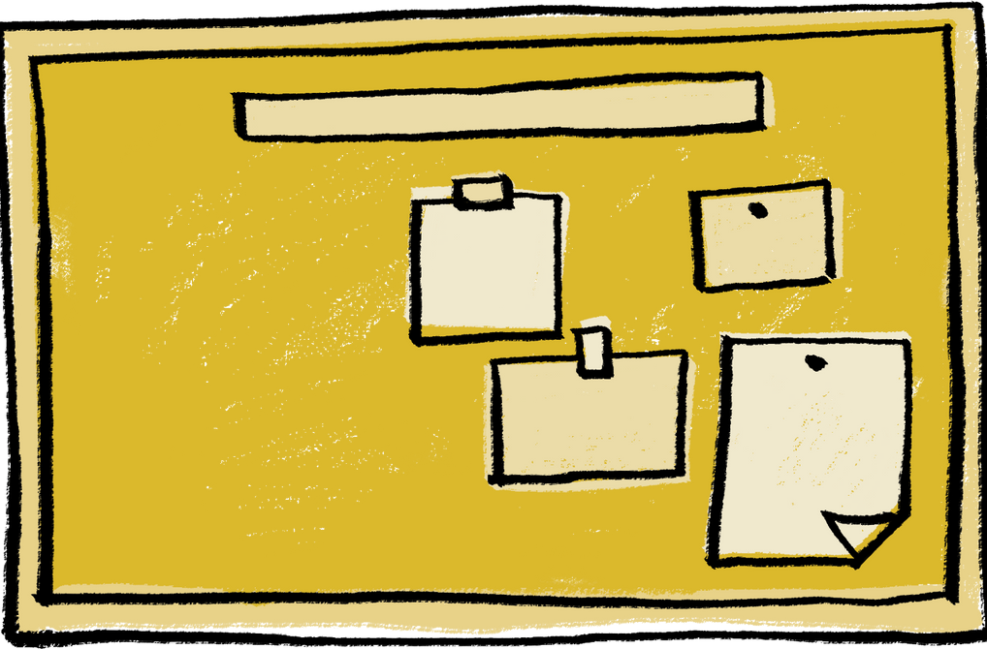

Notes

* Note ideas or changes for next week
* Reﬂect on wins and challenges from this week
* Use this space for anything else

